Bullying Prevention
Liberty Preparatory School is committed to providing a safe and healthy environment for students to learn and grow.
Harassment, intimidation, or bullying is strictly prohibited and will not be tolerated.
Definition of Bullying
Harassment, intimidation, or bullying means:
A. any intentional written, verbal, electronic (i.e., internet, e-mail, cellular telephone, personal digital assistants (PDA), or wireless hand-held device), graphic, or physical act that a student or group of students exhibits toward another particular student(s) and the behavior both causes mental or physical harm to the other student(s) and is sufficiently severe, persistent, or pervasive that it creates an intimidating, threatening, or abusive educational environment for the other student(s); OR
B. violence within a dating relationship.
Reporting
Any student or student's parent/guardian who believes s/he has been a victim of bullying or knows about someone who is being bullied should do one of the following:
- Immediately report the situation to the building principal or supervisor.
- The student may report concerns to teachers and other school staff who will be responsible for notifying the appropriate administration.
- Complete a report through the “Safe Schools Online”
- Complete a report by phone Safe Schools Help Line 1-866-LISTEN2ME
- Complete the form titled “Harassment, Intimidation, or Bullying Complaint Form”
Retaliation against any person who reports, is thought to have reported, files a complaint, or otherwise participates in an investigation or inquiry concerning allegations of aggressive behavior, is prohibited and will not be tolerated. Such retaliation shall be considered a serious violation of Board policy and independent of whether a complaint is substantiated. Suspected retaliation should be reported in the same manner as aggressive behavior. Retaliation may result in disciplinary action as indicated above.
Deliberately making false reports about harassment, intimidation, bullying, and/or other aggressive behavior for the purpose of getting someone in trouble is similarly prohibited and will not be tolerated. Deliberately making false reports may result in disciplinary action as indicated above.
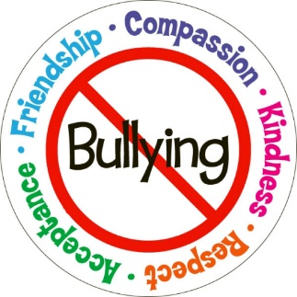
Anti-Bullying Initiatives
Liberty Preparatory School is committed to providing a safe and healthy environment for students to learn and grow. Every two years, we assess our school climate by asking students for feedback on how their school experience is going and whether they may see or experience forms of bullying. Knowing this information helps our staff to target strategies to prevent bullying and harassment at school.
3313.666 Ohio Revised Code
This policy requires that a semi-annual written report will be provided to the Board President and published on the district website that identifies the number of reported incidents and verified acts fitting the definition of harassment, intimidation, or bullying, based on the Ohio Department of Education Anti-Harassment, Anti-Intimidation, or Anti- Bullying Model Policy.

School Year | Harassment | Intimidation | Bullying
2019-2020 | 0 | 0 | 0
2020-2021 | 0 | 0 | 0
2021-2022 | 0 | 0 | 0

